The Success Plan module allows you to track students' progress in their Success Plans. Each Success Plan contains Steps for students to complete. Each Step represents a type of task, such as visiting a center, responding to a survey, uploading a document, and more. Success Plans can additionally be chained together, prompting a new Plan to be created when one Plan is completed.
- Create your Plan
Your Success Plan “type” contains the individual steps, emails, and options that will affect how you track student progress.
- Assign Plans to Students
Success Plans can be assigned to individual students, or multiple students at once from the Student Listing. When a Plan is assigned, any “Plan Started” or “Step Started” email types you’ve created will immediately be sent.
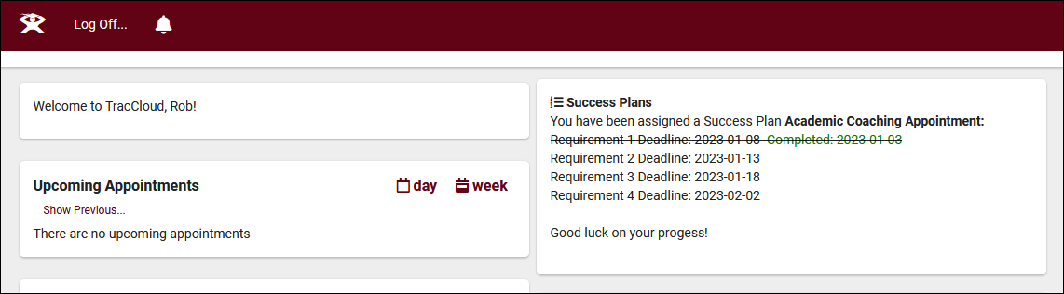

- Monitor Success Plan progress and confirm Step Completion
From the Success Plans tab in student profiles, you can view their current and past plans as well as their completion percentage and status. You can also confirm and override Step completion from this menu if your Success Plan options allow it.
