All You Need to Know About Visits
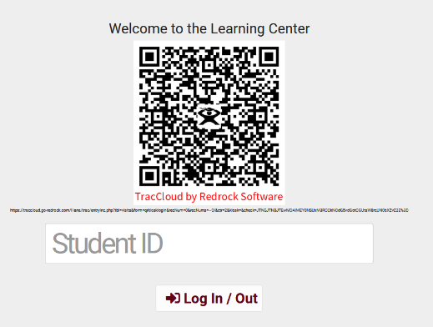

Kiosk
- The Kiosk is used by students to log themselves into or out of your center. This page generally operates similarly to the log listing, but with much stricter permissions and fewer visit management utilities, as we're expecting students to be interacting with this page directly.
Log Listing
- The Log Listing can be used by staff members to log students into or out of your center, or to review who is currently logged in with on-going visits. If wait time is being tracked, this page would also be used to manage visit statuses and coordinate which consultants will be assigned to their visits.
Quick Visits
- Allow you to track a visit if the student may have not signed in, track an email or phone call interactions
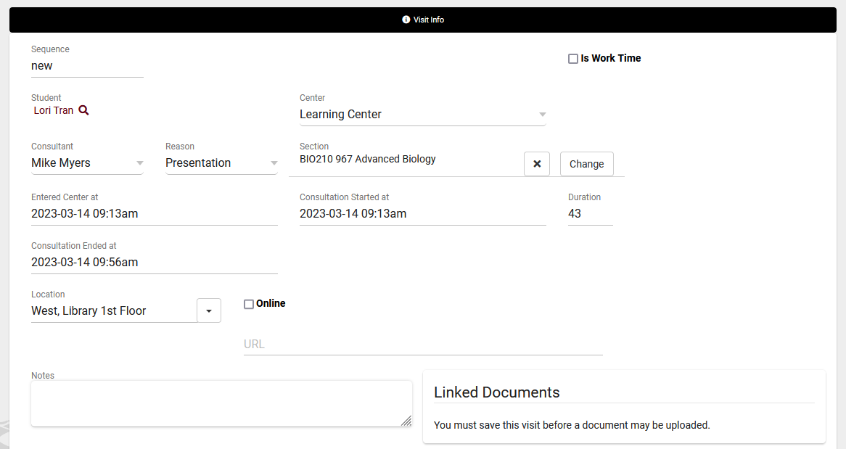
- You can fill out all the specific data you need including notes and any custom fields

Batch Visits
- Can be used for recording visits that happened in the past or workshops and SI sessions
- You can create a batch code so you can edit the criteria and add more students in the future
- Creating a batch code also creates a QR code for your students to scan and sign themselves up for the batch visit. Useful for workshops, SI sessions, and more.

