New SysAdmin
Congratulations on your role to sysadmin of the TracCloud system. I know you are probably wondering where do you start? Below are some resources on the best ways to “get started”.

- Request A Demo: https://www.go-redrock.com/demo/
- Redrock Wiki FAQ: https://wiki.go-redrock.com/index.php/FAQ
- Contact Support by HelpDesk/Ticket System: https://go-redrock.kayako.com/conversation/new
- Contact Support by Phone: 877-303-7575 option 1
(Emergency – System down, can’t access anything! Option 3!)
- Schedule A Training: https://www.go-redrock.com/help-support/request-training/

Starting the team is a easy as
Other > Preferences > Terms
All one needs to do it make sure IT is sending over the current data files, create the term on the back end with the active start and end dates and with a slip of a toggle button, activate or deactivate your terms!

Do you have new hires starting for the new semester? Tutors, Advisors, Consultants, Front Desk Workers, etc, whatever their title we need a staff account created so they can access the Trac system!
How do we start? Simple! On your Dashboard click on Other > Listing > Staff
Click the hamburger drop down icon (), then “New Staff Member”

Deactivating an old account is as quick as a simple check box inside the pre existing staff account!

What about reports? How do we automate the reports in the system.

Saving a Report as a Favorite
Find a report that you plan on coming back to? Save it as a favorite for quick access later. From the report results window itself, click the star icon in the top-left corner, choose a name for your favorite, and click save.
- Allow Group Access will make this report visible to other staff members in your Permission Group.
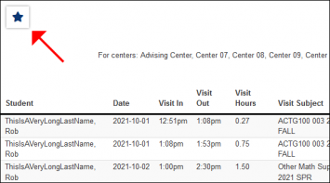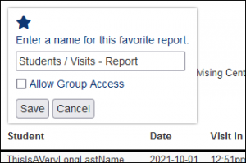
This report can then be found from your dashboard under Reports > Favorites at any time.
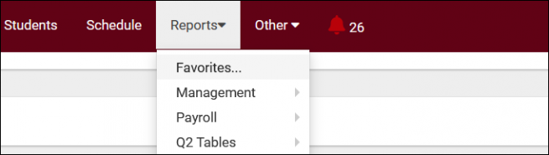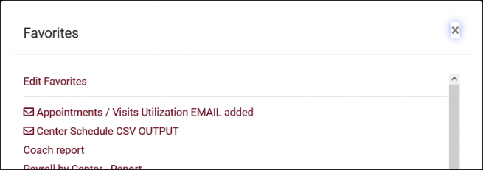

Automating a Favorite Report
After saving your report as a favorite, you can automate it to run on a set schedule and be emailed to you or a group of users.
Start by going to Reports > Favorites > Edit Favorites. This will bring you to the following screen. Click on the Pencil icon of the report you want to automate.
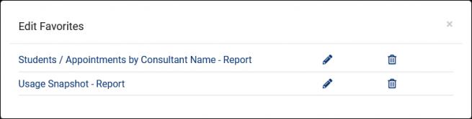
- Deliver to: should be set to Email in this case.
- Email Address(es) is where you'll add your recipients' email addresses. Multiple addresses can be entered, delimited by a semicolon.
- Enable Automation will enable automation and make the following options available.
- Message to include in the report email will add in some custom messaging to your emailed report.
- Automated report frequency. Do you want this report to run daily, weekly, monthly, or once on a specific date?
- Time will determine the time that this report will run on your scheduled frequency.
- Overwrite This Favorite Report will overwrite your existing report settings with your new automation rules.
Click save to apply your changes.
