New Feature: Search Appointment Links (QR Codes)
The appointment links feature allows for the creation of preset search availability widgets, facilitating easy sharing with students via QR codes or links. These links are customizable with additional filters such as subject selection, center or consultant preferences, and meeting modalities/types.
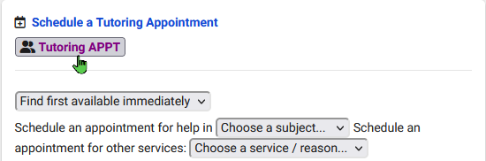
Furthermore, users can enable "Show Dynamic Codes" to generate unique QR code links with selected center/consultant records without creating entirely new appointment link records.
The following QR code has been configured with the following options:
- Center: Learning Center
- Reason: General Tutoring
- Subject: Bio*
- Staff: Luis Frias
When scanning the QR code below, students will be redirected automatically to view all of Luis's availabilities for the specified Center, Subject, and Reason above.
Give it a try!
When prompted to login:
Username: 1918 Password:1918
