Resources are the different items that you may check in and out to your students. These items can range from textbooks, to calculators, laptops, and more. No matter the item, TracCloud can track these items in your systems database, allow staff to check out/in resources to students, track the history of each item, and report all of this data.
- Types
Resources can be given different categories; such as books, calculators, etc.
- Icons
When tracking resources, icons will appear to quickly identify the status of each resource. These statuses include inactive, active, reserved, and checked out.
- Creating a Resource
When creating a resource; be sure to fill out the barcode, title, profile, collateral/collateral logic, who reserved the resource, if it’s always available, different dates, resource type, length of checkout, max renewals, description, and keywords. Further definitions can be found on the back side of this hand out.
- Emails
Whenever a resource is checked out or overdue, TracCloud will automatically send an email to whoever checked out the resource. For overdue emails, we can have the system send out an email every x number of days the resource is not brought back.
- Group Permissions
We can use groups to specify if a staff can log resources in/out, view the resources that a student has logged out, and allow to manage resources.
- Terms and Conditions
TracCloud allows you to link a “Terms and Conditions” document to a resource type. This allows you to convey the policies around this resource type and record student acknowledgement.
- Logging Resources
To log in/out a resource, navigate to Other > Log Resource. In this menu, we will search for an item in the first text box, specify if we are checking out/returning/renewing/un-reserving the item, collect collateral (if needed), then check out.
- Resource Report
TracCloud offers a resource report that will show who has checked out/in an item, checkout date/time, and total hours. This report can either be run on overall Utilization, or specifically on Past Due resources.

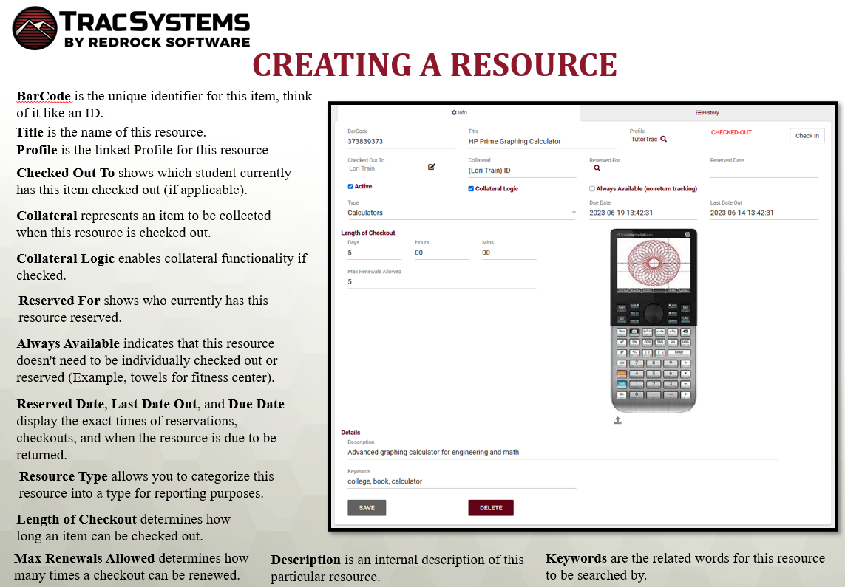

Find more information on Resources here: https://wiki.go-redrock.com/index.php/TracCloudGuideBasicsResources
Or scan the QR code below:
