Visit Settings & Configuration
Reasons
- Reasons/Services allow your staff and students to provide additional information and reasons for booking an appointment. For example, reasons such as “Counseling,” “Study Plan Help,” or “Exam.” This would let the consultants know what the student needs help with, provide preparation details and information as needed, and gives your staff additional information for reports.
Profile Visit Settings
- Ask Student Satisfaction on Logout & Ask Consultant Satisfaction on Logout
Enabling these options adds a "please rate your satisfaction" question to the logout process of both the log listing and kiosk. These responses are only accessible to groups who have been provided access to these fields in the 'Student / Visit' tab. Responses will be visible on the student listing and in reports such as Visits by??.
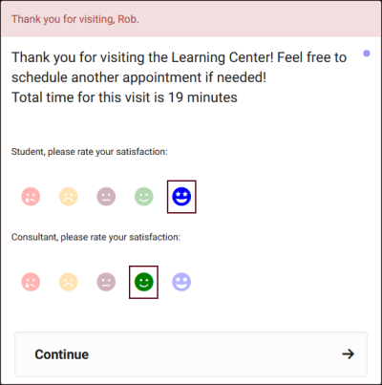
Global Visit Settings
- Hide student login from class roster list
If checked, the visit start/stop buttons in availability group rosters will be disabled. 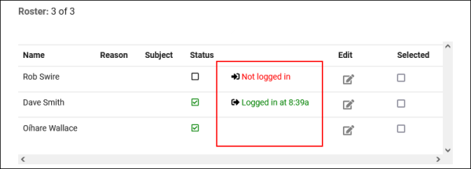

- Custom Fields
Custom fields can be configured throughout TracCloud to store additional data that your campus may require

Announcements
- Announcements are messages that can be displayed to different users on the dashboard of the Trac System. These messages can be set to only display during a specified date range, and can be formatted in a number of different ways to better support your use-case.

Terms & Conditions
- Terms & Conditions allows you to create a prompt that appears for students when they're logging in or booking an appointment. The prompt will contain a custom message, which the student will have to agree to before continuing. While Terms/Conditions are of course the typical use-case, this feature can also be used for any purpose where a student would need to agree to a statement before having full access to the system. 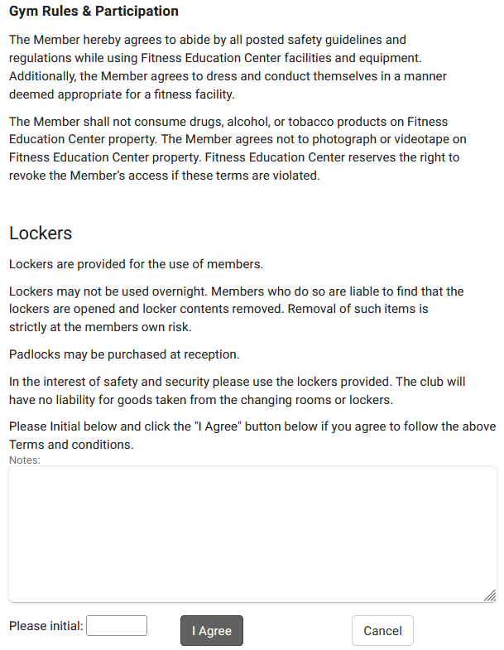
Visit Emails
- Send Visit Notes to Coach, Advisor or Student
Can be used to send visit information to any of the previously named users, or more. The prompt to send this email can appear on individual visit records to be selected by staff, or it can be automatically initiated during visit conclusion. One of the most common uses for this feature is for Consultants to send their Visit Notes (and general Visit information) to faculty.

