Staff Profiles
Do you have new hires starting for the new semester? Tutors, Advisors, Consultants, Front Desk Workers, etc, whatever their title we need a staff account created so they can access the Trac system!
How do we start? Simple! On your Dashboard click on Other > Listing > Staff
Click the hamburger drop down icon (), then “New Staff Member”
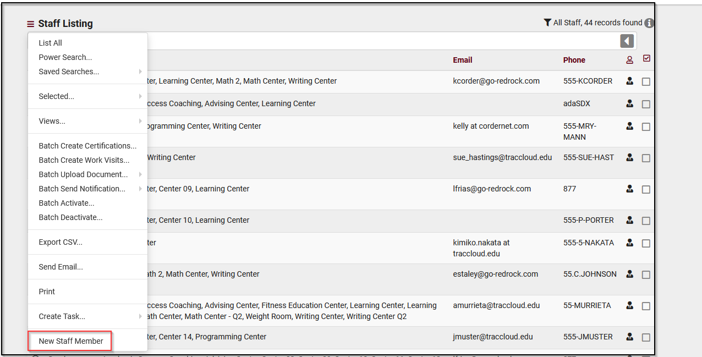

Staff can be defined as members whose primary job is to focuses on logging students in and out of the system, booking appointments on behalf of the student and running reports.

For any type of staff account please fill out the following
- Full Name: The staff member’s full name.
- Username: This is the username that this staff member will use to login. (Have a student worker? Make sure their username matches their student account!)
- Primary Group: This field decides their permissions group in the Trac System, exactly what they can and can’t access, as well as the centers they can manage.

If Consultant is checked this will give you access to some additional fields such as the following:
Alias (for schedule) – Determines what Name is displayed on the scheduled view for students when searching for appointments.
Online Link – Is the place holder for the virtual meeting room students will be automatically re directed to if the appointment is an online session
Center Staff Link Field – this allows you to choose the centers that the schedule will be created for this induvial worker.
Course List of Specialties – Personalize a list of sections and courses this staff member can assist in. This will allow the search function to populate the related sections as the results for students based on this listing.

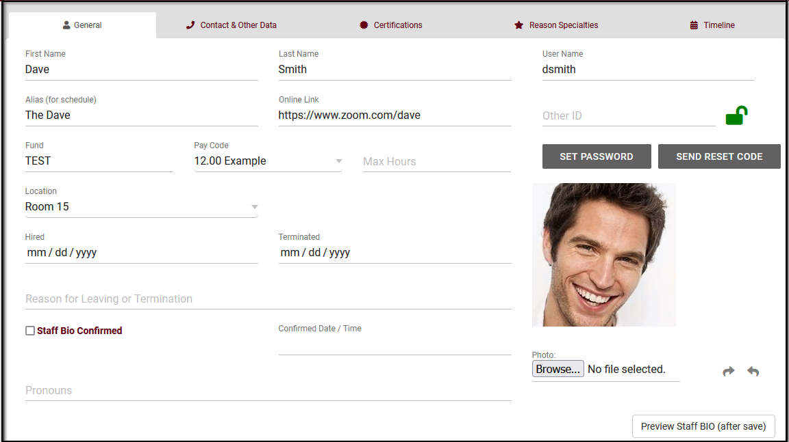
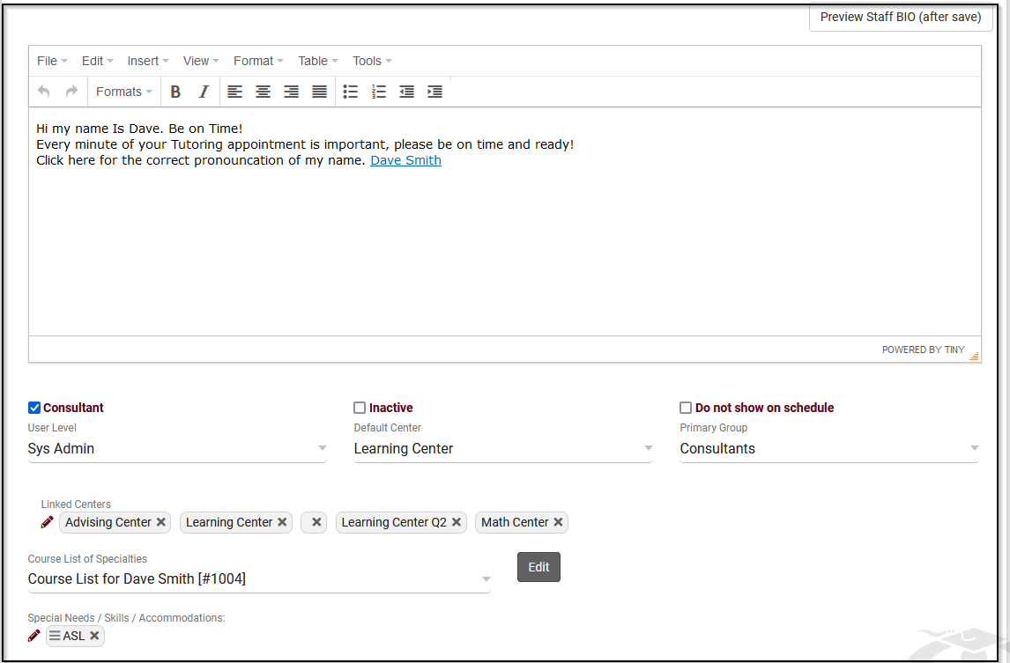

Student View
One of the most common questions we get is “What can my students see?”
Students will be able to authenticate into the system using your campus SSO System (using their campus credentials to login to TracCloud)
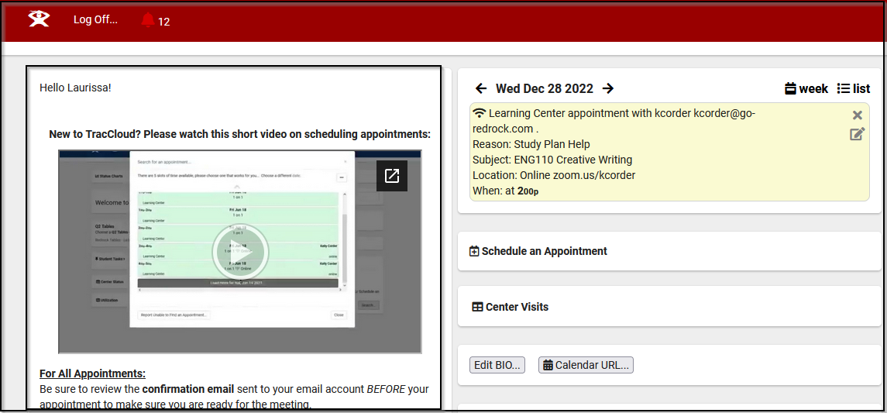
Students will see a very simplified view of the system. It can hold a welcome message (personalized using Twig) to address the student by name. The welcome message can hold anywhere from additional text info/written directions on how to use the system, imbedded links to “how to” videos created from your campus or even display a contact phone or email address.

Students will also be able to see an appointment summery of the details of their appointment (that you as SysAdmin can personalize under Other>Other Options > Profiles > Prefs > Scheduling > Appointment Display ). This summery can detail information such as Center, Staff Member Contact Information, Reason and Subject the appointment is booked for, Physical or Online Location and Time Frame. Or it can be simplified to just display Time, Subject and Reason.

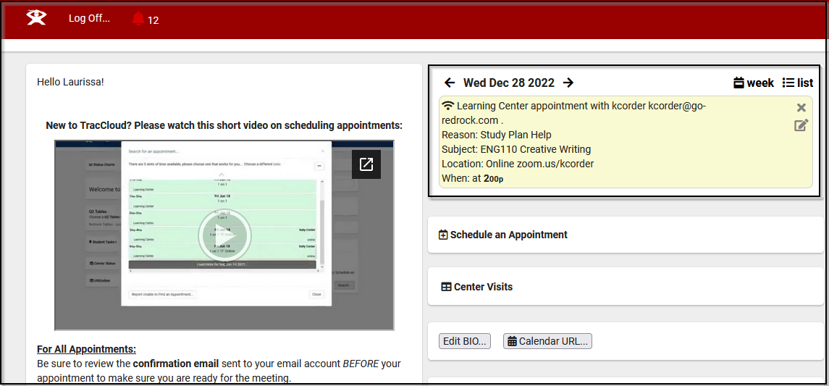
When looking for availability students will be able to search of the subject for the courses, they are enrolled in.
Or even narrow down the reason for services they want the appointment results for.

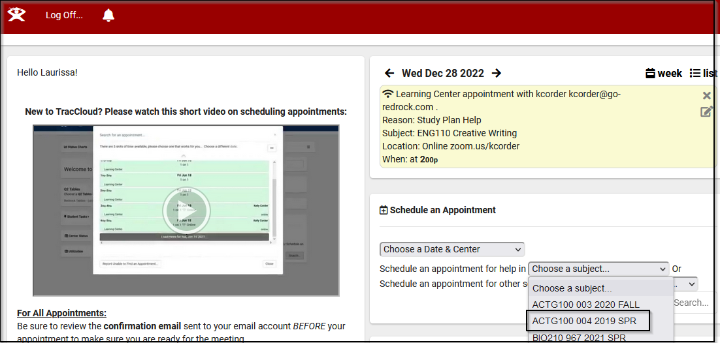
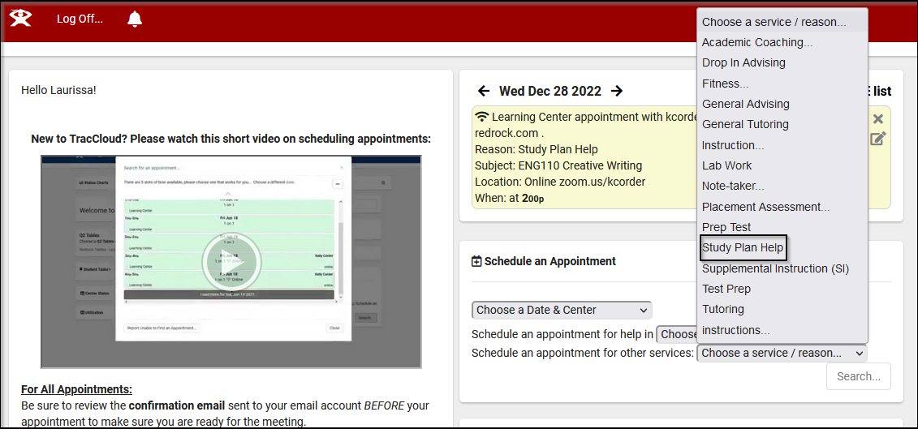

We can also allow students to view their OWN (and only their own) visits for a specified date range. This might be helpful for students that have required hours or need to bring documentation to their athletic coach.

