Resources

Resources are materials that can be checked out by staff member (based on group permissions) to a student. What is the purpose? Lets say you allow students to lend a graphing calculator when they come into the math center.
First we would need to create a resource in the system to check out.

To begin creating a resource, go to Other > Resources > Resources (List), then click the + icon to create your new resource.
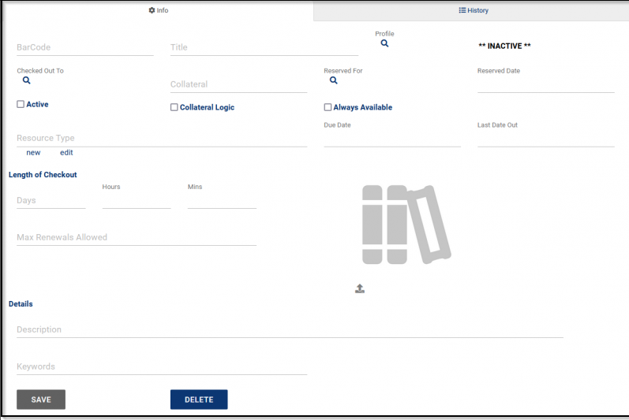

The following fields SHOULD be filled out
Barcode: A unique identifier for this item. Can be used to log resources in and out via a barcode scanner or swipe system.
Title: The name of the resource item
Keywords: Related words for this resource – can be used to make filtering easier
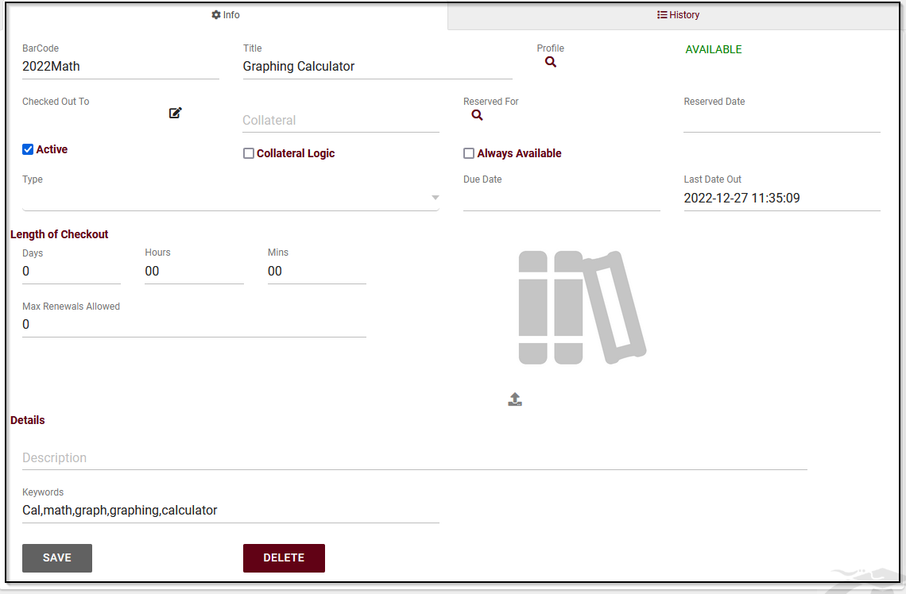

Now that our resource has been established on the backend, we can check this item out for a student to utilize! From the Dashboard click on Other > Log Resource
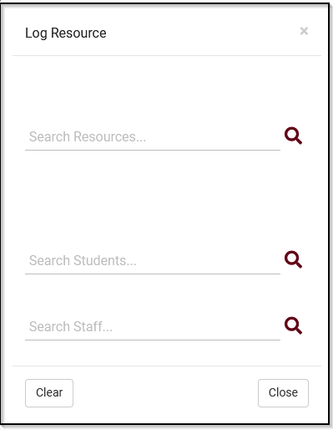
Simply enter the Resource Item Name (or keyword) to locate the item you want to check out to the student. Then also identify the student that item is getting lent out to.
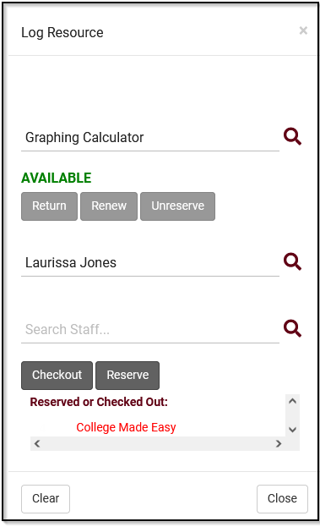

Resource emails can also be customized (using the Twig Tag) to inform students of the due date of their checked-out resource, or if the resource is overdue. These options are part of your Profile Preferences.

Bonus:
In addition to checking items out to students, they can also be checked out to staff members!
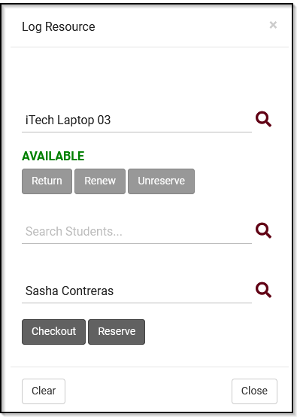

For more helpful tips on Resources, Resource Emails and Reports please visit our wiki page: https://wiki.go-redrock.com/index.php/TracCloudGuideBasicsResources

