Listing Search Examples
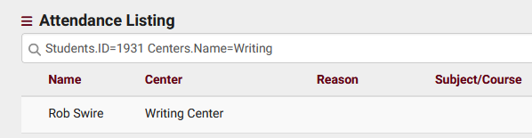
Visit Listing Example Searches:
- Find a visit by Student ID:
Students.ID=1931
- Search by Center Name:
Learning Center
- Multiple field search:
Students.ID=1931 Centers.Name=Writing
- Search in Custom Fields:
#sql:Student_Remarks#=Great
- Date searches (formatted as YYYY-MM-DD):
Visits.TimeIn=2022-03-15
Date ranges:
2022-06-01...2022-07-01
- Exact time:
Visits.TimeIn="2022-03-15 15:30:00"
- True or False value search:
Visits.IsWork=1
- Find visits that conflict with a student's section schedule:
Visits.CustomData/isLoggedDuringClass=1
Student Search Examples:
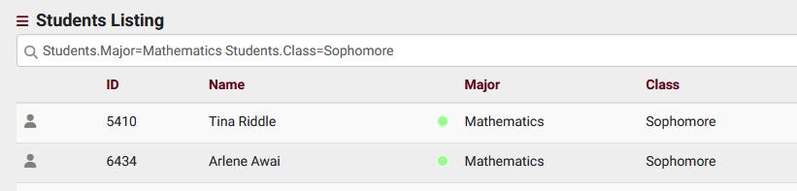
Single Value Searches:
  - Finding a student by ID: Students.ID=1931
Finding a student by name (formatted as 'Last, First' or 'First M Last'):

- Day, Rob
Searching Multiple Fields Simultaneously:
- Searching for students majoring in Mathematics and are Sophomores:
- Students.Major=Mathematics Students.Class=Sophomore
Handling Spaces in Searches:
- When performing multiple searches where at least one field contains a space, use quotation marks:
- Students.Major="Chemical Engineering" Students.Status=Active
Searching in Custom Fields:
- Utilizing custom fields, recommended to use the right-click menu for correct autofill:
- #sql:InState#=Yes
Date Searches:
- Date searches must be formatted as YYYY-MM-DD:
  - Students.BirthDate=1993-07-16

