Q2 Study Tables Module
What is Q2?
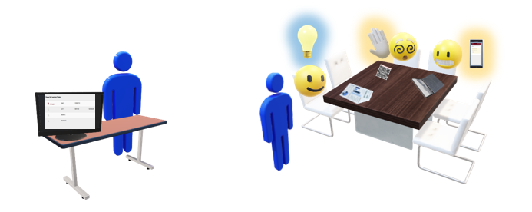
Q2 Tables dynamically manages independent study and work table scenarios, tracking the total time a student spends in the center and also recording each individual contact a student has with a Staff. Q2 Tables is a redesign of a log in and out system, specifically for study table centers where students work on their own or study independently, but can request assistance as needed. Students who need assistance can raise their hand to be placed in a Queue, Students can request help physically or electronically with the use of their mobile device. Tablets and Mobile devices drive the queuing system for students requesting assistance as well as providing staff with a real time view of all students in the center studying independently as well as students requesting assistance. Student and staff Q2 contacts can be reported on specialized Q2 report which will provide break downs of the students helped, staff who assisted, Student's independent Study time and wait time as well as the duration of each interaction with a staff.
Using Q2 Remote for Online Drop-in Sessions
Q2 can also be utilized in an Online context. The staff’s availability will be set to Drop-in, Online, with the Online URL set to Q2Remote.
As a student, they can search for and click on this Drop-in session as usual.
However, clicking 'Enter Online Session' in this case will take the student to the Q2 form rather than a meeting room. This allow the student to specify what they need help with and will virtually raise the students hand in the Q2 queue, and the student will wait at this form until a link is ready.
As a staff member monitoring this Q2 config, they will see a student has their hand raised for a remote session. Clicking on that entry prompts the staff to send the student a remote meeting link, such as a Zoom or Webex room.
And once again as a student, the meeting link will appear on the Q2 form, which the student can click to join. After the visit has concluded, the staff member will lower the student’s hand and the student can request help again if needed.

