All You Need to Know About Visits
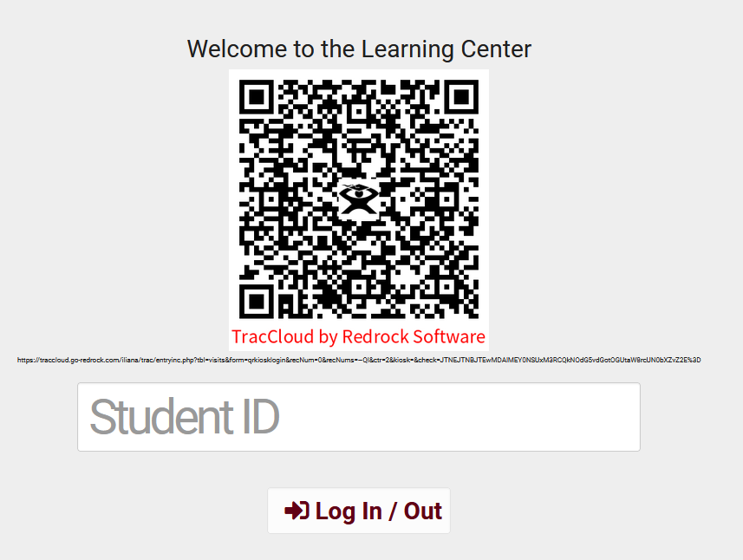
Student ID
- In this field, students can enter unique identifiers to login. This can be any information such as their school ID, email, or even name.
QR code
- Kiosk can have a QR code for the Students to scan the code with their mobile device and login without touching the kiosk.
Quick Visits
- Allow you to track a visit if the student may have not signed in, track an email or phone call interactions
- You can fill out all the specific data you need including notes and any custom fields
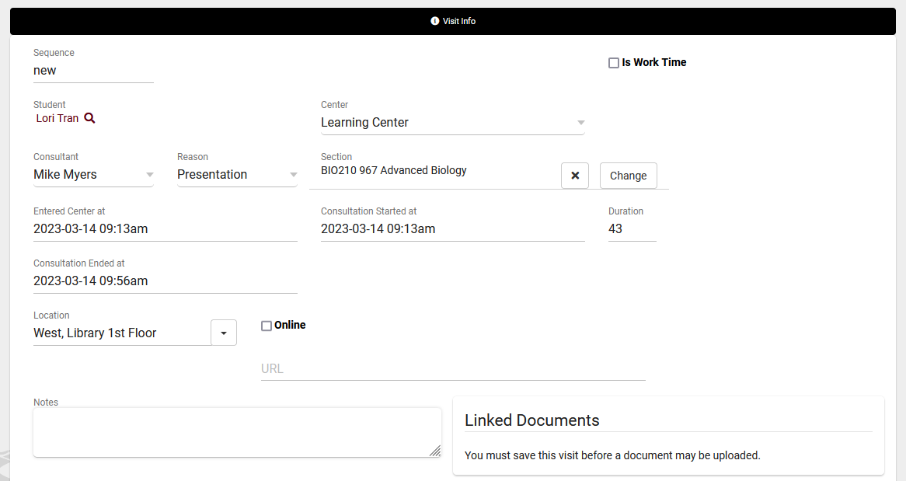
Batch Visits
- Can be used for recording visits that happened in the past or workshops and SI sessions
- You can create a batch code so you can edit the criteria and add more students in the future
- Creating a batch code also creates a QR code for your students to scan and sign themselves up for the batch visit. Useful for workshops, SI sessions, and more.

