TracCloud receives frequent updates that are automatically applied to your instance. Some of these updates are smaller tweaks and improvements, while others bring entirely new features that may benefit your usage of the Trac System. There are two ways you can review new changes on your Trac System.
- Feature Highlights on the Redrock Wiki
Notable additions or changes receive short articles to bring you up to speed on new updates.
https://wiki.go-redrock.com/index.php/TracCloudWhatsNew
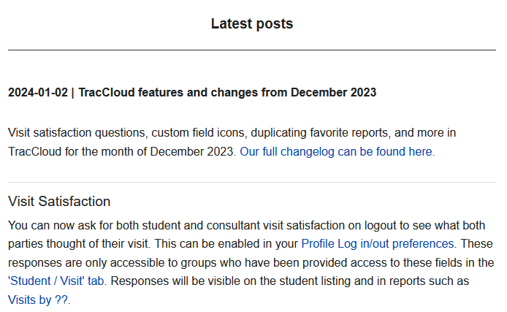
- Full Changelog
If you want to view a complete list of changes rather than the highlights, the full changelog lists everything. A shortcut to this wiki article can also be accessed through TracCloud by going to Other > View Latest Changes.
https://wiki.go-redrock.com/index.php/TracCloudChangelog
