REDROCK SOFTWARE
CORPORATION

March 29th-April 1st, 2023
16th Annual Redrock Conference

2023
Conference
Program

29 Years of Success Strategies for Your Campus

Welcome!

Thank you for participating in the 2023 Redrock Software Conference! We are excited to return to the Phoenix Chandler Hilton to celebrate our 16th annual event.

We hope you take advantage of the amenities of this beautiful facility. Chandler Fashion Mall is close by and includes dozens of restaurants all within walking distance. The Hilton also provides excellent Wi-Fi Internet access to all of our guests.

Mother nature has provided our wonderful weather and while the average temperature this time of year is 85 degrees, you may get a taste of our wonderful dry Arizona heat. Arizona is known for many cultural attractions such as museums, sporting events, world-class golfing, casinos or maybe just relax by the pool.

Please take a moment to read through the sessions we are offering. There is a great variety including user presentations, presentations by the Redrock staff, question and answer sessions, and one-on-one sessions (available on a limited basis) on Saturday morning. Signups will be available on Friday after lunch with Laura Reed in the lobby.

The most unique aspect of our annual conference is YOU and all the other TracCloud users. We hope you can take advantage of this time to meet and get to know other users. This is a wonderful networking opportunity and we hope you develop relationships to help you and your programs grow.

We are here to serve so don’t hesitate to ask. Thanks again for attending the 2023 Redrock Conference!

The Redrock Team

Redrock Software Corporation

Kelly and Jennifer Corder founded Redrock more than 26 years ago with the desire to be a leader in educational technology. With the creation of FitnessTrac in 1995, Redrock quickly evolved its Trac engine to accommodate the technology needs of diverse centers in colleges and universities. One of our favorite parts of our job is meeting with educators and leaders who enable us to improve our product and processes.

We are always trying to grow to meet the needs of our family of cherished customers and employees, and welcome your input. We have been a family-centered organization from the very start – and we hope you feel part of our family too. Thank you for your participation!

GET OUT OF YOUR HOTEL ROOM!

Break away from the conference grind and join the Redrock Software Team for dinner at the hotel or to Macayo’s Mexican Restaurant. Transportation will be provided for those that sign up, but you can still join us on your own if you have your own transportation. There may be a limited number of spots available so sign up early. Contact Laura Reed at laura@go-redrock.com to sign up for one of the Redrock Software sponsored activities!

Dine with Redrock at the Hotel (Papago), Thursday 6:00pm

Personnel from Redrock Software will be dining in the room Papago after the conference Thursday evening. We look forward to having you join us!

Dine with Redrock at Macayo’s Mexican Restaurant on Friday 6:00pm

Personnel from Redrock Software will be dining at Macayo’s Mexican Restaurant Friday evening. We have reserved a block of tables for the Redrock team and conference attendees to enjoy a meal together. Redrock is not paying for the meal, just organizing the activity and will provide transportation.

Schedule at a Glance

Wednesday, March 29th, 2023

Time Session Location
12:00pm – 4:00pm Conference Registration Foyer
1:00pm – 2:00pm Introduction and Demonstration of TracCloud Mojave
2:00pm - 2:10pm Afternoon snacks available Foyer
2:10pm – 3:10pm TracCloud Technicals: Systems, Security, Availability Mojave
3:20pm – 4:20pm What’s New in TracCloud Mojave
5:00pm – 7:00pm Welcome Reception with Dinner Poolside

Thursday, March 30th, 2023

Time Session Location
8:00am – 4:00pm Conference Registration Foyer
8:15am - 8:45am Welcome to the 2023 Redrock Conference Mojave
8:45am – 9:00am Morning Snacks Available Foyer
9:00am - 9:50am Personalizing TracCloud – Welcome page, Announcements and more! Mojave
TracCloud Terminology Hopi
10:00am - 10:50am Pencil Me In: TracCloud Scheduling Mojave
Q2 Study Tables Module Hopi
11:00am - 11:50pm Latrice Bowman, University of Alaska Fairbanks - “Post-Pandemic Changes
and TracCloud Reporting” Mojave
Communicating with Users by Email or Text Hopi
11:50pm – 1:00pm Lunch Papago
1:00pm – 1:50pm Alaina Peters, University of Cincinnati - “TracCloud: A Year in the Life” Mojave
Success with SAGE Hopi
2:00pm – 2:50pm General Reports & Options Mojave
Student and Staff Setting Hopi
2:50pm - 3:00pm Afternoon snacks available Foyer
3:00pm - 3:30pm 2023 Conference Recap Mojave
3:30pm – 5:00pm Redrock Software Personnel available for questions Foyer

Thursday Evening Activities

6:00pm Dinner with Redrock at the Hotel Papago

Schedule at a Glance

Friday, March 31th, 2023 – School Spirit Day – Wear Your Colors!

Time Session Location
8:15am - 8:30am Friday Morning Welcome, Announcements Mojave
8:35am - 9:25am Tracey McDonnell Wysor, Roger Williams University –
“Essential Reporting Features of TracCloud” Mojave
Scheduling - Set Up and Configuration Hopi
9:25am – 9:40am Morning Snacks Available Foyer
9:40am - 10:30am All You Need to Know About Visits Mojave
SurveyTrac Hopi
10:40am - 11:30pm Dude Coudret – University of Arizona
Enhancing Your Trac System for You and Your Students Mojave
New SysAdmin - A Guide to Getting Started Hopi
11:30am – 12:30pm Lunch Papago
12:30pm – 1:20pm Mark Woolwine, University of Louisville – “A Year in the trenches
with TracCloud” Mojave
Let's Review the Data Hopi
1:30pm – 2:10pm Success Plans Mojave
Trac(k) Resources Hopi
2:20pm - 3:00pm Alaina Peters, University of Cincinnati – “TracCloud Success Plans:
Increasing Student Transparency, Engagement, & Compliance” Mojave
Reports, Data & Scheduling Q&A Hopi
3:00pm – 3:10pm Afternoon Snacks Available Foyer
3:10pm – 4:00pm 2023 Conference Wrap-Up, Feedback, and Open Q&A Forum Mojave
4:00pm – 5:00pm Redrock Software Personnel available for questions Foyer

Friday Evening Activities

6:00pm Dinner with Redrock at Macayo’s Mexican Restaurant Foyer

Saturday, April 1st, 2023

Time Session Location
8:30am – 11:00am One-on-One Appointments Mojave

Guest Presenters

Dude Coudret – University of Arizona

Dr. Dude Coudret is an engaging and enthusiastic educator and leader in higher education, possessing over 20 years of experience partnering with students, faculty, and staff. He is known for developing innovative approaches to meet changing campus needs, enhancing collaborations and partnerships, and improving the quality of academic and learning experiences/services. Dude consults on and facilitates training on a range of topics, including active learning, bias, disabilities, empathy, health disparities in the LGBTQ+ communities, inclusive learning design, leadership, mindset, the Myers–Briggs Type Indicator, the science of learning, and team and organizational development. Dude has a Bachelor of Science and a Master of Science in Education, from the University of Dayton (UD), in Dayton, Ohio. His doctoral work at Arizona State University (ASU) focused on understanding feelings of shame in medical school and fostering shame resiliency. Dude is currently the Director of Student Development at the University of Arizona’s College of Medicine in Phoenix. In addition to his full-time work, Dude also teaches doctoral-level courses for Arizona State University's Mary Lou Fulton Teachers College. Dr. Coudret has been a AdvisorTrac user at two institutions and for over decade. AND yes, Dude is his real name!

Alaina Peters – University of Cincinnati

Alaina Peters (she/her/hers) has worked in the University of Cincinnati Learning Commons as an Academic Services Administrator since August 2021. In this role, she oversees the one-on-one appointment-based Peer Tutoring program, partnerships with Student-Athlete Support Services, and TracCloud processes. Beginning in January 2023, she also began leading Success Plan partnerships for students required by campus partners/colleges to attend Learning Commons services. Alaina has a Master’s degree in Higher Education/Student Affairs from The Ohio State University, a Bachelor’s degree in Music Education from Arizona State University, and is currently pursuing a Graduate Certificate in Blended Online Learning & Teaching at the University of Cincinnati. Her professional interests include experiential learning, support for high-achieving students, and the intersection between academic and student affairs. When not at work, Alaina enjoys conducting and performing in her community band, learning Vietnamese, and taking introductory tango lessons!

Latrice Bowman – University of Alaska Fairbanks

I have lived in Alaska for about 37 years and enjoy the challenges and experiences of living here. I have been at the University of Alaska Fairbanks for 23 years. I have a masters in applied mathematics and a doctorate in education. I teach most levels of mathematics, coordinate our graduate students, and am in charge of hiring/training/supervising our undergraduate tutors and graders. Because of my many responsibilities, I have used TutorTrac and TracCloud since 2017 to make some of my jobs a little easier.

Mark Woolwine – University of Louisville

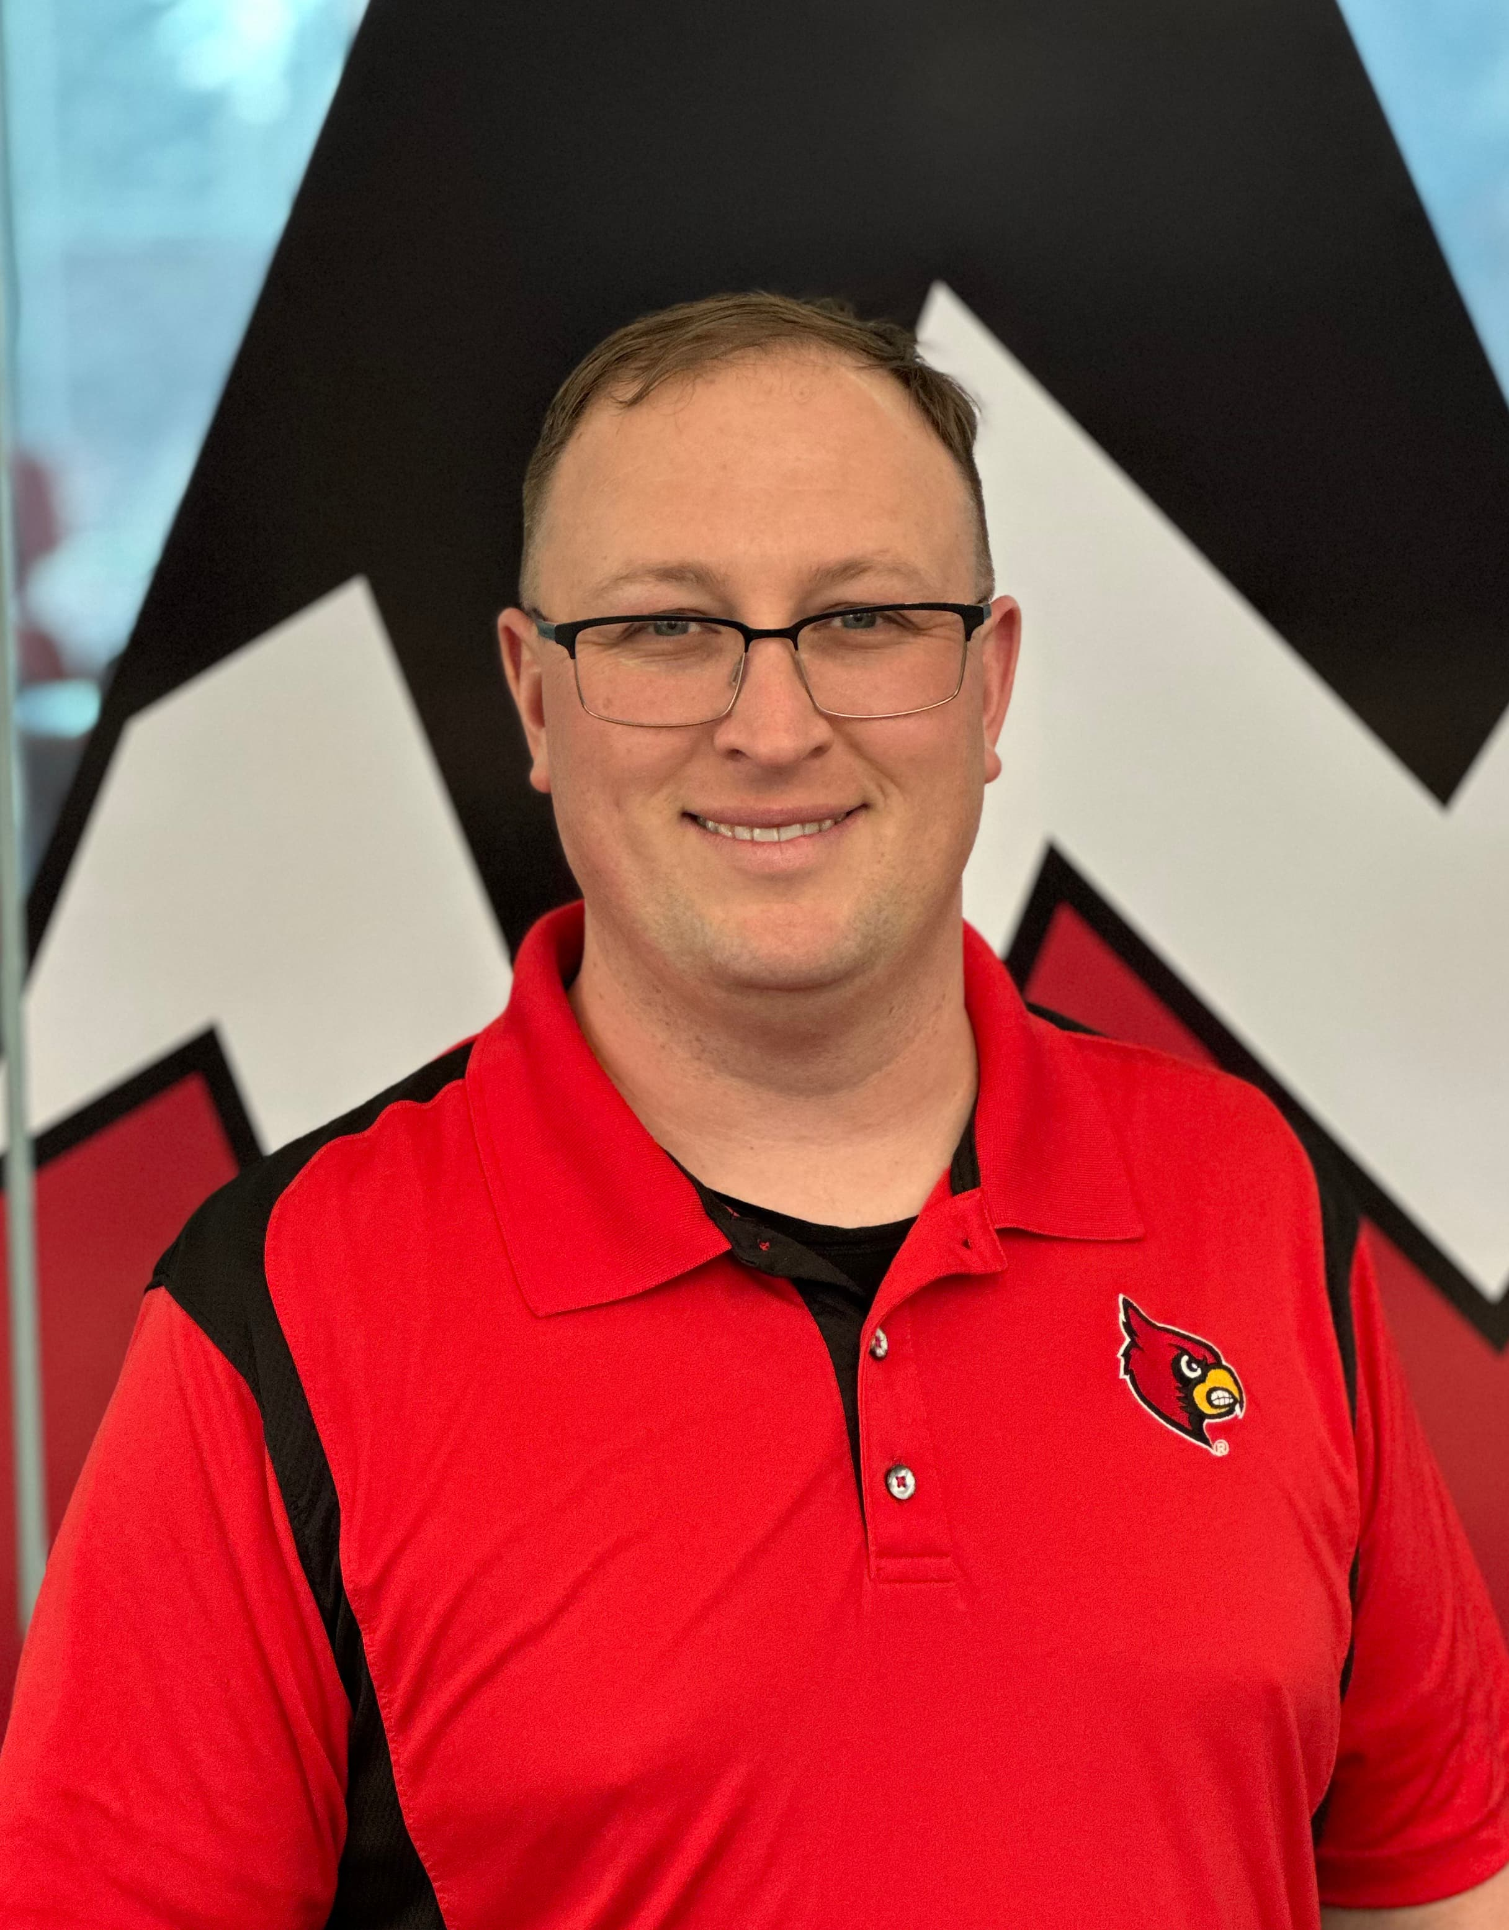
Mark is the Assistant Director for Learning Resources at the University of Louisville in Louisville, KY. In this role, Mark oversees the scheduled tutoring program, assists with Academic Coaching, coordinates the university co-requisite college reading courses, and co-coordinates TracCloud for the university. He lives in Louisville, KY with his wife Sarah, daughters Leah (5) and Clara (3), and their miniature schnauzer Louie.

Tracey McDonnell Wysor – Roger Williams University

Tracey McDonnell Wysor is the Assistant Director of the Tutoring Center at Roger Williams University where she also teaches in the Department of Biology, Marine Biology and Environmental Science. Tracey has a background in Marine Biology and Education and serves as a principal investigator on a ‘Scholarships in STEM’ grant awarded by the National Science Foundation. Tracey’s varied roles position her to connect students, faculty and support staff in strategic ways that promote the mission of the university. Tracey loves living in the Ocean State with her three kids, two dogs, and one husband.

Thank You!

Our presenters are the best! Thank you for taking the time, energy and effort to share your knowledge and experiences with the Trac systems and modules. Your insights and expertise with the Trac systems are invaluable to the future developments of the Trac system and to your fellow Trac users. The annual Redrock Software Conference would not be the same without your willingness to share with and support other Trac System users.

Thank you for attending! We know you have to fight for your budgets and take precious time away from your classes and families to be here. We strive to provide a fun and friendly learning environment for every participant. Please let us know how we can continue to improve and make the software, our support, and the annual conference even better.

We like to reward our conference attendees! For those that attend the 2023 conference, we are offering a $600 discount on our new Student Success Module and 10% off all other modules and/or profiles for TracCloud if a quote is requested at the conference and purchase is made by 4/30/2023. Please see Laura or email her at laura@go-redrock.com to request a quote.

Thank you for being a part of the Redrock Family!

- The Redrock Team

Redrock Software Corporation

Kelly Dean Corder, President

In 1991, Kelly Dean Corder founded Redrock Software Corp with his wife Jennifer with a desire to help businesses succeed. In the beginning, he consulted for businesses such as McDonnell Douglas (now Boeing), the Phoenix Suns and Arizona Diamondbacks, American Express and others. In 1995 he created FitnessTrac and so began his relationship with center management software for colleges and universities. Aside from working side-by-side with his wife and son, Kelly loves seeing how campuses help students graduate and lead productive lives. Kelly is a graduate of the University of Phoenix. When not developing software, Kelly is teaching or training in martial arts. He holds black belts in four different disciplines of martial arts.

Jennifer Corder, Vice President
Jennifer Corder has been with Redrock since the beginning in 1991 and has been involved in many functions, namely sales, marketing, office management, and accounting. Jennifer is an Arizona native and graduate of Arizona State University. She enjoys cooking, genealogy, true crime documentaries and traveling.

Laura Reed, Sales and Marketing Manager

Laura Reed has been with Redrock for almost 22 years as a sales and marketing manager. She is often the first person a prospective customer deals with and she manages our email communication, contact database, scheduling, as well as invoicing. Laura has an ideal situation as she works from home and loved the flexibility it gave as she raised her four children. She currently has three kids at college and one in high school. During her free time, she enjoys volunteering, reading a good book, going on a date with her husband, playing volleyball, tennis, or pickleball, or spending time with family.

Nicolas Corder, Software Developer

Nicolas Corder has been a lifelong member of Redrock, originally stuffing envelopes as a child, later moving to sales by attending many NCLCA, CRLA, NACADA and other conferences.
Nicolas is a lead TracCloud developer, manages Redrock cloud services, and is our chief security officer. Nicolas is married, an Eagle Scout, a martial arts instructor, and has two cats and a dog.

Everett Staley, Software Developer
Everett Staley has been with Redrock Software for almost 5 years. He is one of the developers of TracCloud. He enjoys doing photography, and spending time with his wife and their two dogs.

Iliana Visser, Technical Support Manager and Sales

Iliana Visser has been with Redrock for over twelve years and is an invaluable member of the Redrock team. She has worked hard to learn all the ins and outs of the Trac products and how to best relay that information to customers. Iliana delivers stellar support and service to Trac customers, provides sales demonstrations, conducts user training, handles technical support issues and conference planning. Iliana enjoys reading, kickboxing, and paddle boarding but most of all she loves spending time with her family.

Luis Frias, Technical Support and Sales

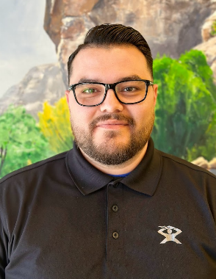
Luis Frias joined Redrock late 2014. He is incredibly knowledgeable of the 4.0 Trac Software and TracCloud and can assist customers with a wide range of support issue. It is tough to beat Luis to a call on the support line, as he is eager to provide customers with answers to their questions. When Luis is not at the office, he enjoys sports and has trained in Martial Arts over the last 8 years. Luis is another Arizona native at Redrock and a true Arizonan as he loves the warm weather.

Sasha Contreras, Technical Support and Sales

Sasha Contreras has been with the Redrock team for about 4 years. She has been interested in technology most of her life and jumped at the opportunity to learn more. Sasha is eager to help clients become more familiarized with the software and become comfortable asking questions of all sorts. She is Inspired daily by her daughter. In her free time, Sasha trains in Hawaiian Kenpo as a second-degree black belt and runs a martial arts dojo with her husband and brother. What she enjoys the most is spending quality time with her two siblings and family by building traditions.

Aidan Murray, Technical Support and Sales

Aidan Murray joined Redrock about 3 years ago, focusing on learning both Trac 4.0 and TracCloud. In addition to conducting sales demonstrations, he provides excellent customer service and technical support. He is to thank for an exceptional documentation and updating the Redrock Wiki. He enjoys working with computers, music, art, and animation.

Erick Martinez, Technical Support and Sales

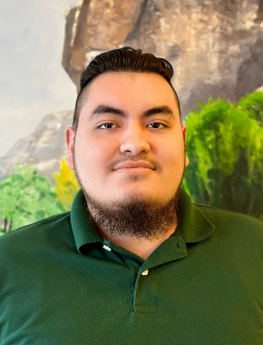
Erick Martinez is one of the newest members of the Redrock team. Focusing on learning the ins and outs of TracCloud. Erick is excited at the opportunity to expand his knowledge and understanding of technology. He enjoys music, traveling, and spending time with family.

Billy Bennett, Technical Support and Sales

Billy Bennett is the newest member of the Redrock team, with a focus on learning the ins & outs of TracCloud while providing excellent service and support. He has always had a passion for technology and is excited to jump into the field. Billy enjoys film, music, and learning about computers in his spare time.

Conference Sessions

Wednesday, March 29th

Pre-Conference Session 1 (Wednesday, March 29th 1:00 PM – 2:00 PM)

Pre-Conf 1: Introduction and Demonstration of the TracCloud
Mojave

Aidan Murray, Redrock Software Corporation
Have your Trac-ing needs changed since your first introduction to TracCloud? Maybe you inherited your system and want to explore its full potential? Here’s a perfect refresher course on what TracCloud can do for you! We will take a general walk-through of our main features, like: logging student visits, managing appointments, importing student data, sending messages, retention tools and generating reports. By the end of this introductory session, you will be able to identify more TracCloud capabilities and gain an understanding of how you can further enhance your own campus TracCloud.

Pre-Conference Session 2 (Wednesday, March 29th 2:10 PM – 3:10 PM)

Pre-Conf 2: TracCloud Technicals: Systems, Security, Availability
Mojave

Nicolas, Redrock Software Corporation
In this presentation we'll be discussing the technical aspects of TracCloud on AWS. We'll explore the architecture of our system and how it is designed for resiliency and availability. We'll also cover the critical yet often overlooked parts of TracCloud's backend that make it all possible. Additionally, we'll provide an in-depth overview of our security model and the measures we've taken to protect our users' data.

Pre-Conference Session 3 (Wednesday, March 29th 3:20 PM – 4:20 PM)

Pre-Conf 3: What’s New in TracCloud
Mojave

Redrock Staff, Redrock Software Corporation
New updates and features are implemented in TracCloud regularly. We record new features and major changes on our wiki and have a changelog available to view within TracCloud, but these can be easy to miss. This session will go over the biggest changes and features added to TracCloud in the past year and how your campus can utilize them.

Thursday, March 30th

Conference Welcome (Thursday, March 30th 8:15 AM – 8:45 AM)

Welcome to the 2023 Annual Redrock Conference
Mojave

Kelly Corder, Redrock Software Corporation
We are very excited for the 2023 Annual Redrock Conference. We are grateful for all of our wonderful customers and are eager to share new software features and releases with conference attendees. You will not want to miss the conference welcome, meet the Redrock team, and receive the first look at current developments!

Session Block 1 (Thursday, March 30th 9:00 AM – 9:50 AM)

Session 1: Personalizing TracCloud
Mojave

Aidan Murray, Redrock Software Corporation
There are many ways you can personalize TracCloud to better fit with your campus theme and provide additional information to users. Everything from customizing your Welcome Messages and Announcements with Twig and HTML, to modifying exactly how Appointments display on the dashboard and staff schedule. This session will go into detail on these, as well as several other options for personalizing your TracCloud instance.

Session 2: TracCloud Terminology
Hopi

Sasha Contreras, Redrock Software
Profile? KIOSK? Hamburger Icon? Learning something new can be frustrating, especially if the directions and linguistic just sound like gibberish to you. Terminology doesn’t have to make your experience unsatisfying. Come learn the common vocabulary Redrock uses to make your TracCloud experience as pleasant as possible! From training your staff to creating a helpdesk ticket, the proper wording will make everything smooth as possible!

Session 3: Open Room
Papago

Have a question or issue you want to walk through? Come to helpdesk and grab a Redrock Tech support member that is free to aid you in a one-on-one support session.

Session Block 2 (Thursday, March 30th 10:00 AM – 10:50 AM)

Session 4: Pencil Me In: TracCloud Scheduling
Mojave

Luis Frias, Redrock Software Corporation
Everything you need to know about scheduling in TracCloud from creating availabilities to viewing and booking appointments, this session has you covered. We will walk through a staff’s view of creating, viewing and booking appointments followed by a student’s general view of booking, viewing and cancelling appointments. We will also discuss Online and In-Person interactions for drop-ins (new), One on One and group interactions which is now built in. Come learn with us as we explore the new options and views with TracCloud Scheduling. Scheduling Settings & Configuration.
Session 5: Q2 Study Tables Module
Hopi

Iliana Visser, Redrock Software Corporation
Q2 Tables dynamically manages independent study and work table scenarios, tracking the total time a student spends in the center and also recording each individual contact a student has with a Staff. Q2 Tables is a redesign of a log in and out system, specifically for study table centers where students work on their own or study independently, but can request assistance as needed. Students who need assistance can raise their hand to be placed in a Queue, Students can request help physically or electronically with the use of their mobile device. Tablets and Mobile devices drive the queuing system for students requesting assistance as well as providing staff with a real time view of all students in the center studying independently as well as students requesting assistance. Student and staff Q2 contacts can be reported on Via a specialized Q2 report which will provide break downs of the students helped, staff who assisted, Student's independent Study time and wait time as well as the duration of each interaction with a staff.

Session 6: Open Room
Papago

Have a question or issue you want to walk through? Come to helpdesk and grab a Redrock Tech support member that is free to aid you in a one-on-one support session.

Session Block 3 (Thursday, March 30th 11:00 AM – 11:50 AM)

Session 7: [User] Post-Pandemic Changes and TracCloud Reporting
Hopi

Latrice Bowman, University of Alaska Fairbanks
In this session, we will briefly look at how UAF's Math Achievement Services uses TracCloud including some of the changes we made due to the pandemic. We will also dive into some of the reports that we regularly use and look at some of the information that they provide.

Session 8: Communicating with Users by Email or Text
Hopi

Aidan Murray, Redrock Software Corporation
How can we effectively communicate appointment and visit information to your students and staff? Your TracCloud system keeps users informed of new appointments, post-visit information, cancelled/missed appointments, and more. Our TextAlerts module adds another communication tool, allowing both students and staff to be reminded of confirmed or upcoming appointments over SMS. This session will detail how you can configure preferences and options relating to your emails and text alerts. We also have options to send instructors and faculty emails about their students' visits – adding more avenues of communication. In this session, you will learn how to take advantage of these messaging features and customize them to your needs.

Session 9: Open Room
Papago

Have a question or issue you want to walk through? Come to helpdesk and grab a Redrock Tech Support member that is free to aid you in a one-on-one support session.

Session Block 4 (Thursday, March 30th 1:00 PM – 1:50 PM)

Session 10: [User} “TracCloud: A Year In the Life”
Mojave

Alaina Peters, University of Cincinnati
The UC Learning Commons first transitioned from Trac 4.0 to TracCloud TutorTrac in Summer 2022, using this new program to improve scheduling and tracking services for our 9 different centralized academic support programs designed to serve the nearly 45,000 students at the University of Cincinnati. Since Summer 2022, we’ve experienced turnover of multiple professional staff (including both of our original SysAdmins) and two trainings for new student staff, so we’ve encountered many obstacles with troubleshooting and external/internal communication. Join this session to learn about how we made changes to improve our systems for both students and staff members, and how we adapted our approaches towards change to effectively balance progress with stability. You’ll walk away able to apply components of this workshop to improve your own transition, troubleshooting, and communication processes for your TracSystem.

Session 11: Success with SAGE
Hopi

Iliana Visser, Redrock Software Corporation
Through the SAGE Early Warning module, the Trac System can provide Faculty and Advisors a means to alert the institution of students who are not making satisfactory progress or are displaying behaviors that could lead to academic attrition. SAGE can be customized to create a multitude of referrals like roster verifications, progress updates for special populations, and even praise notifications. With the ability to track submitted referrals, send automated emails to custom recipients, and host it all online, SAGE can easily become a student referral system that prompts faculty buy-in. When designed with actionable items, SAGE referrals help develop a communication link between students and faculty, support services personnel, and counselors that often continues beyond the initial alert. The need for an effective early warning system has never been greater and SAGE can provide you with the effective solution for your institution.

Session 12: Open Room
Papago

Have a question or issue you want to walk through? Come to helpdesk and grab a Redrock Tech Support member that is free to aid you in a one-on-one support session.

Session Block 5 (Thursday, March 30th 2:00 PM – 2:50 PM)

Session 13: General Reports & Options
Mojave

Luis Frias, Redrock Software Corporation
This session will include a detail and thorough look at several TracCloud reports and report options. I will show off a brand-new interface with several new functions. Some new functions include bar chart, Pie charts and the ability to exports all reports into excel at a push of a button. This is your one stop shop to learn all you need know about reports in TracCloud. Join us as I show you how to take full advantage of your TracCloud Reporting capabilities!

Session 14: Students and Staff Settings
Hopi

Sasha Contreras, Redrock Software Corporation
Do you need to create new hires in your system? Curious what peer tutors can access? This session will dive into the settings for setting up your staff and preview group options when setting up those needed permission groups. We will also demonstrate what a student view in the system can look like and how a peer tutor can toggle back and forth between their student and staff account.

Session 15: Open Room
Papago

Have a question or issue you want to walk through? Come to helpdesk and grab a Redrock Tech Support member that is free to aid you in a one-on-one support session.

Thursday Closing Session (Thursday, March 30th 3:00 PM – 3:30 PM)

Thursday Recap, Review, and Announcements
Mojave

Kelly Corder, President of Redrock Software Corporation
Join the Redrock Team and review the information that was presented during the Thursday sessions. We have been pleased to work with you and provide this in-depth training for you. This final session will review the conference and allow for an open question forum. Bring any questions and comments regarding any session topic or about the conference in whole. The entire Redrock team will be available to answer your questions during this session.

Friday, March 31st
SCHOOL SPIRIT DAY! WEAR YOUR COLORS!

Friday Welcome (Friday, March 31st 8:15 AM – 8:30 AM)

Welcome, Announcements, and New Features
Mojave

Kelly Corder, Redrock Software Corporation
With a full day of conference sessions completed, join the Redrock team as we review session topics, and answer questions. Conference attendees receive a first-hand look at development items and new features before they are released to the public. Come see what is in store for the future of Redrock and your TracCloud Systems.

Session Block 6 (Friday, March 31st 8:35 AM – 9:25 AM)

Session 16: [User] Essential Reporting Features of TracCloud

Mojave

Tracey A. McDonnell Wysor, Roger Williams University
The RWU Center for Student Academic Success utilizes TracCloud to manage and track all tutoring and advising services at the University. This presentation will demonstrate the numerous ways TracCloud allows the Center to collect data, and the critical reporting that the system enables the Center to provide to stakeholders (administration, faculty, and staff).

Session 17: Scheduling - Set Up and Configurations

Hopi

Luis Frias, Redrock Software Corporation
In this session our main focus will be more on settings and configurations of the schedule rather than creating availabilities and appointments. We will discuss scheduling related rules, permissions, bios for center and staff and scheduling related reports. Join us for a full discussion about the configuration and setup for your TracCloud schedule for Students and Staff.

Session 18: Open Room
Papago

Have a question or issue you want to walk through? Come to helpdesk and grab a Redrock Tech Support member that is free to aid you in a one-on-one support session.

Session Block 7 (Friday, March 31st 9:40 AM – 10:30 AM)

Session 19: All You Need to Know About Creating Visits
Mojave

Iliana Visser, Redrock Software Corporation
Visit data provides the essential data to review your services. It is the primary function of every tracking system, from paper and pencil to spreadsheets to your TracCloud. The visit data assists with everything from evaluating student success, to acquiring funds for your program. While there are many tools available to record visits, the Kiosks and the Log Listings provide flexible, real-time login services to your students. Participants in this session will review the basics of the login features, as well as discover some more advanced options to customize your login processes. Come and see why the Kiosks and the Log Listing are the preferred methods for recording your visits.

Session 20: SurveyTrac
Hopi

Aidan Murray, Redrock Software Corporation
One of the powerful modules that can be added to your Trac System is SurveyTrac. SurveyTrac can be used to gather feedback about meetings with students as well as provide forms that can be saved to student records. In this session, we will tackle the key aspects of creating and managing surveys in TracCloud. We will also cover reporting on results, resending unanswered surveys, and additional ways you can personalize the emails and formatting of your questions.

Session 21: Open Room
Papago

Have a question or issue you want to walk through? Come to helpdesk and grab a Redrock Tech Support member that is free to aid you in a one-on-one support session.

Session Block 8 (Friday, March 31st 10:40 AM – 11:30 AM)

Session 22: [User] Enhancing Your Trac System for You and Your Students
Mojave
Dude Coudret, University of Arizona
The scheduling tool for your Trac System has a wide range of flexibility, and with this flexibility comes a wide range of settings and configurations. In this session will discuss several System Admin level settings and configurations for your center profile and Trac System. Join us as we review basics scheduling rules as well as touch on a wide range of scheduling preferences only available to System Administrators.

Session 22: New Sysadmin - A Guide to Getting Started
Hopi

Sasha Contreras, Redrock Software Corporation
Congratulations on your new role! Where do we start?
This session will do just that! Come learn how to create and manage your staff, look at or adjust schedule rules and email templates and change over the new semester for the active term. Wanting to create a list of students for those reports? We will go over that too!

Session 23: Open Room
Papago

Have a question or issue you want to walk through? Come to helpdesk and grab a Redrock Tech Support member that is free to aid you in a one-on-one support session.

Session Block 9 (Friday, March 31st 12:30 PM – 1:20 PM)

Session 24: [User] A Year in the trenches with TracCloud
Mojave

Mark Woolwine, University of Louisville
This session will overview the University of Louisville’s first year with TracCloud. We will share our successes and challenges faced over the past year. We will showcase how we trained our professional and student staff to use TracCloud, how we use email templates and automation to market our services, and selecting the appropriate report to get the data you may need.

Session 25: Let's Review the Data
Papago

Luis Frias, Redrock Software Corporation
The focus of this session is to take your knowledge of the Reports in TracCloud and take things to the next level. In this session we will discuss FTE options, other statistical information data and views, Favorite reports as well as the automation of reports. We will also discuss in-depth the permissions and other settings related to the access of reports. This session will NOT include an overview of reports in general and it is encouraged to go to the session General Reports & Options for a complete overview of reports. Join us to learn more about report settings, automation and more as we explore additional options pertaining to TracCloud Reports.

Session 26: Open Room
Papago

Have a question or issue you want to walk through? Come to helpdesk and grab a Redrock Tech Support member that is free to aid you in a one-on-one support session.

Session Block 10 (Friday, March 3st 1:30 PM – 2:10 PM)

Session 27: Success Plans
Mojave

Aidan Murray, Redrock Software Corporation
The Success Plan module allows you to track students' progress in their Success Plans. Each Step represents a type of task, such as visiting a center, responding to a survey, uploading a document, and more. Success Plans can additionally be chained together, prompting a new Plan to be created when one Plan is completed. This session will give you an overview on how Success Plans could be used for you and your institution.

Session 28: Trac(k) Resources
Hopi

Sasha Contreras, Redrock Software Corporation
Did you know that your Trac system can also track the items? Join us to learn about how your Trac system can function as a lending library to monitor the usage of textbooks, calculators, and more! Any items you might allow a student, or staff member, to utilized in order to make their experience at your center the best it can be! This session we will cover all aspects of resources from creation, management, and reporting.

Session 29: Open Room
Papago

Have a question or issue you want to walk through? Come to helpdesk and grab a Redrock Tech Support member that is free to aid you in a one-on-one support session.

Session Block 11 (Friday, March 31st 2:20 PM – 3:00 PM)

Session 30: [User] TracCloud Success Plans: Increasing Student Transparency, Engagement, & Compliance
Papago

Alaina Peters, University of Cincinnati
The UC Learning Commons partners with over 10 colleges and programs at the university who require specific student populations (probation, alert, first-year students, etc.) to attend a specific number of services each semester. With our recent (Summer 2022) transition to TracCloud/TutorTrac from Trac 4.0, we have used an additional tab in students’ TracCloud profiles to increase student accountability and transparency about their requirements and improve communication with campus partners assigning Success Plans. Attendees will learn about the Learning Commons’ approach to managing campus-wide Success Plans for specific student populations, identify technical processes needed to implement similar Success Plans at their own institution, and generate ideas on improving student compliance and assessing the effectiveness of Success plans. A demonstration of what these Success Plans look like in UC’s TracCloud will be included.

Session 31: Reports, Data, & Scheduling Q&A
Hopi

Luis Frias, Redrock Software Corporation
In this wrap up session we will have open Q&A discussion about all things Data, scheduling and report related. We will cover Visit and Appointment Data as well as the various Reports discussed throughout the conference. Bring your questions as this session will be an open discussion to answer any inquiries you may have regarding how information is viewed, stored and reported on in your TracCloud system.

Session 32: Open Room
Papago

Have a question or issue you want to walk through? Come to helpdesk and grab a Redrock Tech Support member that is free to aid you in a one-on-one support session.

Conference Closing Session (Friday, March 31st 3:10 PM – 4:00 PM)

Conference Wrap-Up, Feedback, TracCloud Implementation Timeline and Open Q&A Forum
Mojave

Kelly Corder, Redrock Software Corporation
Thank you for attending the 2023 Redrock Conference! We have been pleased to work with you and provide this in-depth training for you. This final session will review the conference and allow for an open question forum. Bring any questions and comments regarding any session topic or about the conference in whole. The entire Redrock team will be available to answer your questions during this session.

Saturday, April 1st

One-On-One Sessions (Saturday, April 1st 8:30 AM – 11:00 AM)

Redrock One-On-One Sessions
Mojave

Redrock Software Support Personnel
Users who have signed up for a session will be able to meet with a member of the Redrock Support Team to discuss their specific needs and implementation. The one-on-one sessions are 30 minutes in length and are schedule back-to-back so please come prepared with your questions.

Session attendees will be able to sign up for the one-on-one sessions after Friday’s closing session with the open Q&A forum (Friday 3:10pm – 4:00pm).

Conference Maps – Meeting Rooms

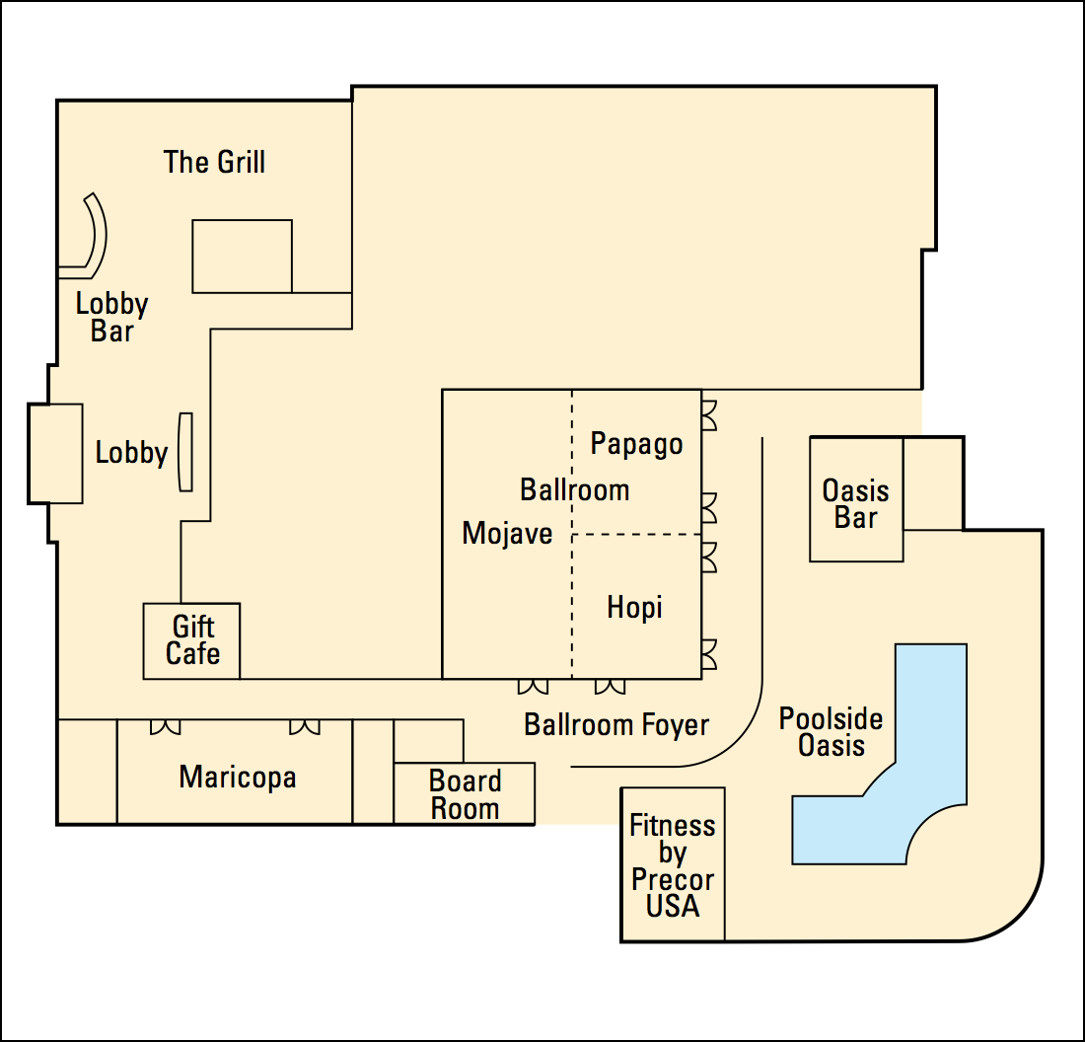

Conference Maps – Airport to Hotel

