New SysAdmin
Congratulations on your role to sysadmin of the TracCloud system. I know you are probably wondering where do you start? Below are some resources on the best ways to “get started”.

- Request A Demo: https://www.go-redrock.com/demo/
- Redrock Wiki https://wiki.go-redrock.com/index.php/Main_Page
- Contact Support by HelpDesk/Ticket https://go-redrock.helpspot.com/index.php?pg=request
- Contact Support by Phone: 877-303-7575 option 1
(Emergency – System down, can’t access anything! Option 3!)
- Schedule A Training: https://www.go-redrock.com/help-support/request-training/

Starting the new term is easy! Please following these steps as
Other > Preferences > Terms
- Make sure IT has sent over the new data files to the SFTP server
- Activate your new term/deactivate the old term
- Process Activations & Process Specialties
- (if needed) please adjust your scheduling rules.

Do you have new hires starting for the new semester? Tutors, Advisors, Consultants, Front Desk Workers, etc, whatever their title we need a staff account created so they can access the Trac system!
How do we start? Simple! On your Dashboard click on Other > Listing > Staff
Click the hamburger drop down icon (), then “New Staff Member”

Deactivating an old account is as quick as a simple check box inside the pre existing staff account!

What about reports? How do we automate the reports in the system.

Saving a Report as a Favorite
Find a report that you plan on coming back to? Save it as a favorite for quick access later. From the report results window itself, click the star icon in the top-left corner, choose a name for your favorite, and click save.
- Allow Group Access will make this report visible to other staff members in your Permission Group.
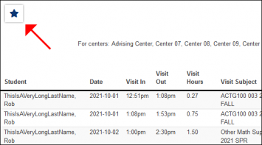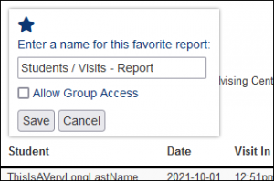
This report can then be found from your dashboard under Reports > Favorites at any time.
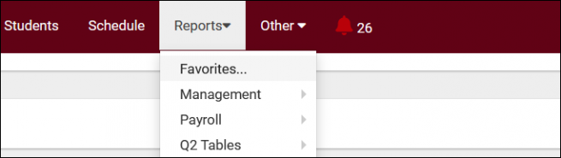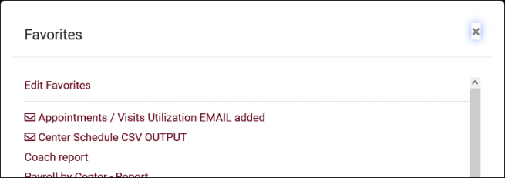

Automating a Favorite Report
After saving your report as a favorite, you can automate it to run on a set schedule and be emailed to you or a group of users.
Start by going to Reports > Favorites > Edit Favorites. This will bring you to the following screen. Click on the Pencil icon of the report you want to automate.
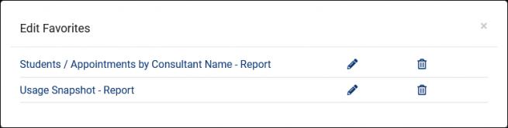
- Deliver to: should be set to Email in this case.
- Email Address(es) is where you'll add your recipients' email addresses. Multiple addresses can be entered, delimited by a semicolon.
- Enable Automation will enable automation and make the following options available.
- Message to include in the report email will add in some custom messaging to your emailed report.
- Automated report frequency. Do you want this report to run daily, weekly, monthly, or once on a specific date?
- Time will determine the time that this report will run on your scheduled frequency.
- Overwrite This Favorite Report will overwrite your existing report settings with your new automation rules.
Click save to apply your changes.
