Reporting Advanced
Symbols that can help you search when using reports.
Group By:
% or * are wildcards
Example
When searching Subject/Course/Section you may want all BIO subjects and courses and sections.
Using the Wildcard will return everything after BIO% the subject. Giving you all Bio Course and sections.
MAT% - All Math subject Courses and sections
MAT1% - All Math subject and courses that start with “1” – Math 101 – Math 103 Math 102 for example
MAT101% All Math subject and courses and any section of Math 101
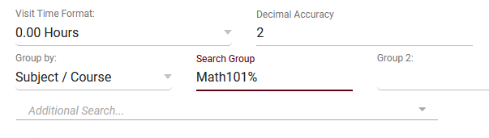
Additional Search:
| is an or
Example: I want MAT, Eng and Bio
Mat%|Bio%|Eng%
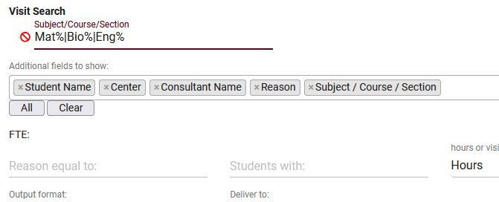
To show all except the following
so saying give me all subjects except for Math related and English Related visits.
#Mat%&&#Eng%
