Learn to create and manage staff availability
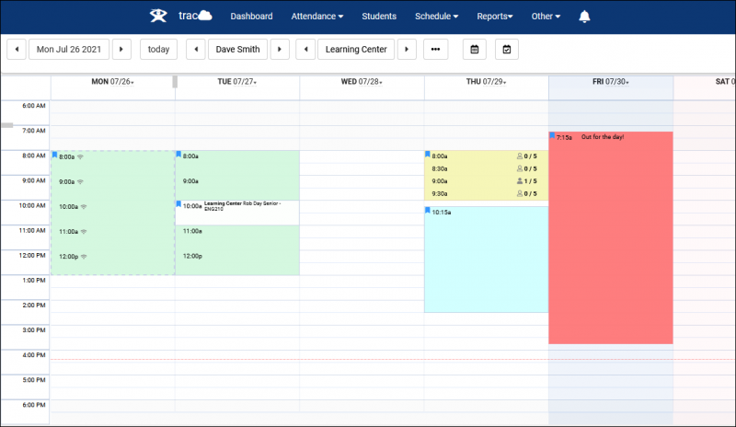
Click and drag to create availabilities on the Staff view of the schedule.

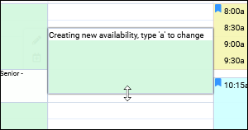
An appointment entry for will appear.
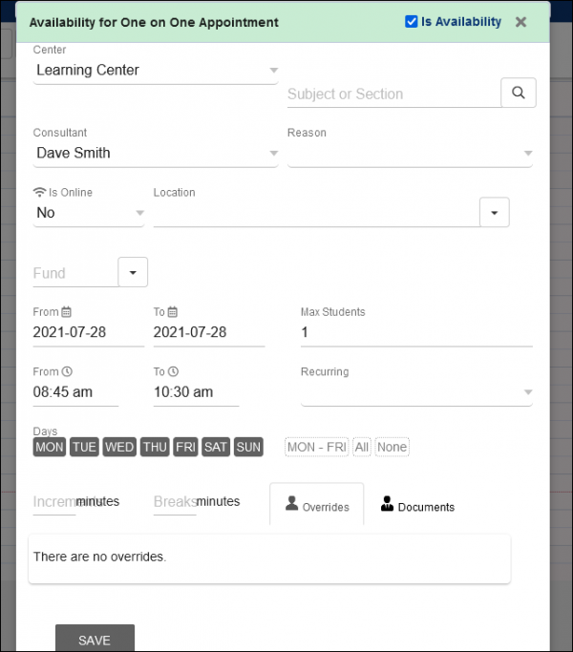
Starting from the top, we can select our desired Subject and Reason. You can select a specific subject, use a * wildcard (such as “ACTG*” for all ‘Accounting’ courses), or leave the field(s) blank. The subjects the consultant is available for will be dependent on their assigned Course List.
The following option, “Is Online,” determines if this is a remote appointment. When the student logs in to join an online appointment, they will see a button on their home screen allowing them to immediately join. This will also mark the appointment as attended and create a visit record.
The “Is Online” setting also affects which Location options are available. If this is an in-person availability, the location options will be determined by your profile settings. If this availability is online, you will be given preset options for conference/breakout URLs (as determined by your System Preferences) in addition to your consultants’ specific static URL.
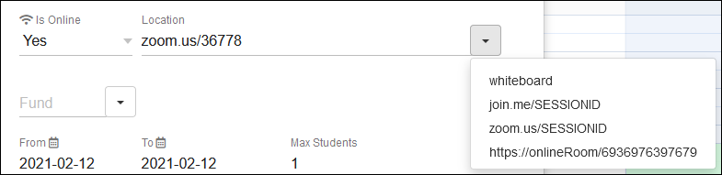
The Max Students option determines the availability type. 0 would be a drop-in event, 1 is a one-on-one meeting, and 2 or more would be a multi-person class.
The date range and days of the week fields allow you to determine how this availability will repeat going forward. By default, just the one day you created the block on will be active, however, you can push the “To” date farther out and deselect the days of the week that this availability shouldn’t be active for to create a schedule such as “Every Monday, Tuesday, and Friday until 1/31/2022”.
Increments and Breaks control how the block is split into different times. If you create a 5-hour block on the schedule, setting the Increments to 60 minutes will split that into 5 1-hour blocks instead. Breaks allow you to schedule breaks for your consultants’ in-between appointments. For example, you could set Increments to 55, and Breaks to 5 to give your consultants 5-minute breaks in between their 55-minute appointments.
Overrides will show you breaks in this series. For example, if you have an availability that repeats for some time, but a block in that series is removed (maybe the consultant isn't available that week or their time changes on that one day), that will appear as an override date for the rest of the series.
Click “Save” once you’re happy with the configuration.
For more about appointment booking open our Wiki: https://wiki.go-redrock.com/index.php/TracCloudGuideBasicsSchedule

